**California University of PA**

**Dept. of Computer Science, Info Systems, and Engineering Technology**

**ACET440 Computer Networking**

**Fall 2022**

**= Lab Report =**

**Lab 6 Phase II: Security**

**Andrew Bissell**

**Joshua Hughes**

**Noah Proctor**

**Date Submitted: 12/04/2022**

**I. Procedure**

Open the virtual desktop and acquire the putty .exe from the putty website (*https://www.chiark.greenend.org.uk/~sgtatham/putty/latest.html*). Enter Draco1.calu.lcl in the host name and set it to SSH. When prompted for a login use your pennwest email and password, take care to enter the password correctly, it will not show the characters or how many are inputted (*Figure 1*). Either import the Lab6.c, Lab6.h, FuncsLab6.c, and Makefile, or create blank files using the touch command and copy each file in using nano. Once all files are in the directory use the make command to compile and get the Lab6 executable, use the ./Lab6 command to execute the program. Once executed the program will check for a log file if there is one it will display the registration status and the last login time. If there isn’t a log file a blank one will be created. Next the user will connect to the server using port number 4401, then use their user ID to log into the server. The Client will now encrypt all messages using the encryption key for the server for added security. From here the user can type in all caps the following commands: HELP, QUIT, REGISTER, MYINFO, ONLINEUSERS, REGISTEREDUSERS. Help gives all the commands available to the user. Quit exits the server and client program but writes the time the user quit the program and if they have been registered (1) or not (0). Register registers the user with the server if they are already registered it will inform them, if the log file even if the user has been registered, they will have to reregister for the log file to reflect that they are registered. Registration will now require the user to make a password so that it will protect the user. The password will require three of the following an upper case letter, lower case letter, special character, and/or a number. My info displays the user’s info such as name, age, GPA, and IP address. Online users will display all active users. Registered users will display all the registered users for the server. The user uses QUIT to disconnect from the server and terminate the program but before the client process closes the file is updated with the log time and if the user registered (1) or did not register (0).

**II. Team Member Contribution**

All team members actively contributed to all parts of the program by completing the output and user-friendly display for all the commands for the server. Every team member conducted tests, proper output of data checks, proof-reading of code/report, and completion of the Lab56report.

*Figure 1: Logging into Draco1*

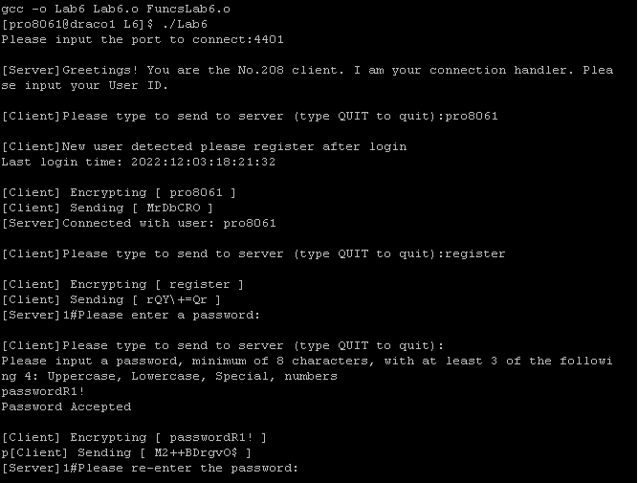

*Figure 2: Proper Operation of the Client Program*